LEVEL 6 — RESEARCH TRACK CAPSTONE
Research Philosophy & Methodology
How to think about research honestly: evidence, decay, and how much of any result to trust
Covers: Economic reasoning before statistical fitting · signal decay / capacity / crowding / alpha decay · data quality · research reproducibility · researcher degrees of freedom · multiple hypothesis testing · false discoveries

Table of Contents
Right-click and choose “Update Field” (or “Update entire table”) after opening in Word to populate page numbers.
Table of Contents 2
6. Research Philosophy & Methodology (Level 6) 3
6.1 Learning Position at a Glance 3
6.2 Economic Reasoning Before Statistical Fitting 3
6.3 Signal Decay, Capacity, Crowding and Alpha Decay 4
6.4 Data Quality 6
6.5 Research Reproducibility 6
6.6 Researcher Degrees of Freedom & Multiple Hypothesis Testing 7
6.7 False Discoveries — Detection and Guardrails 8
6.8 Worked Exercise — Model Answer 8
6.9 Common Mistakes — Deeper Look 9
6.10 Advanced Extensions 9
6.11 Professional Applications 9

6. Research Philosophy & Methodology (Level 6)
Covers: Economic reasoning before statistical fitting · signal decay/capacity/crowding/alpha decay · data quality · research reproducibility · researcher degrees of freedom · multiple hypothesis testing · false discoveries

6.1 Learning Position at a Glance
- What it is: The meta-discipline of how to think about research honestly: what counts as evidence, how many ‘looks’ at the data you’ve really taken, and how much of any result to trust.
- Why it matters: This is what separates a research team that consistently finds durable, sized-appropriately edges from one that repeatedly deploys strategies that stop working within months.
- Prerequisites: Statistics (Depth 4+); Backtesting; several completed research projects (Level 3–5) to reflect on.
- Connects to Research: This is the philosophical foundation the entire research track has been building toward.
- Connects to Development: Reproducibility infrastructure (Level 4) exists specifically to support the discipline this section describes.
- Connects to Trading: Understanding alpha decay and crowding directly informs when to reduce size or retire a strategy.
- Practical exercise: Audit one of your own past strategies for ‘researcher degrees of freedom’ — list every parameter, universe choice and data cut you tried before settling on the final version, and estimate how much of the reported Sharpe ratio might be attributable to that search.
- Common beginner mistakes:
- Not tracking how many strategy variations were tried before finding one that worked (invisible multiple testing).
- Treating a strategy’s initial backtest Sharpe as its expected live Sharpe, ignoring decay and crowding.
- Advanced extensions: Formal pre-registration of research hypotheses; deflated Sharpe ratio and other multiple-testing-corrected metrics.
- Professional applications: Research governance at systematic funds; honest self-assessment of strategy pipelines.

6.2 Economic Reasoning Before Statistical Fitting
Every research process can start from one of two directions. It can start with a story — a reason, grounded in how markets, participants or institutions actually behave, that a mispricing or risk premium should exist — and then go looking for data to test that story. Or it can start with the data itself: run a search across thousands of possible signals, keep whatever survives a backtest, and worry about the explanation afterwards, if at all. The second approach is not wrong because it is lazy; it is wrong because it inverts the burden of proof. With enough data and enough computing power, a purely statistical search will always find patterns that look significant by chance, and nothing in the backtest itself distinguishes a real, monetisable relationship from an artefact of the specific sample being mined.
This is sometimes summarised as ‘theory before data’: articulate the mechanism — a structural flow, a behavioural bias, a regulatory constraint, a liquidity-provision cost — that would make a pattern persist out of sample, before running the statistical test that checks whether the data are consistent with it. The economic story does not need to be elaborate, but it needs to survive a simple question: if this relationship is real, who is on the other side of the trade, and why do they keep making the same mistake or accepting the same cost?

Dimension | Statistical mining first | Economic reasoning first
Starting point | Search a large universe of candidate signals for statistically significant relationships | Articulate a mechanism (flow, bias, constraint, cost) that should produce a persistent effect
Role of the backtest | Primary evidence — a good Sharpe ratio is treated as sufficient justification | Confirmatory — checks whether data are consistent with a pre-specified mechanism
Multiple-testing exposure | Very high; the number of ‘looks’ at the data is often untracked | Lower; the hypothesis space is constrained before the data are touched
Failure mode | Overfits to sample-specific noise that has no reason to persist | Can miss patterns with no obvious story, even if genuinely tradeable
Typical out-of-sample outcome | Sharp, rapid decay once live (see §6.3) | More gradual decay, closer to in-sample expectations

⚠ Case study: spurious correlation
- A widely-cited example pairs US stock market returns with an unrelated series — such as butter production in a specific country — and finds a statistically striking correlation with no economic mechanism connecting the two.
- The correlation is real in the historical sample and completely useless going forward, because nothing about butter production causes, or is caused by, US equity returns; the relationship is a coincidence of two series that happened to trend together.
- The lesson generalises: statistical significance answers ‘could this pattern have arisen by chance in this sample?’, not ‘will this pattern persist?’ — only an economic mechanism speaks to the second question.

6.3 Signal Decay, Capacity, Crowding and Alpha Decay
Four related but distinct concepts describe why a strategy’s live performance is almost never as good as its backtest, and why it tends to get worse over time even without any change in the underlying code.
- Signal decay: The gradual weakening of a predictive relationship as the underlying economic driver itself fades — a regulatory loophole gets closed, a market structure inefficiency gets arbitraged away by infrastructure improvements, or a behavioural bias is educated out of the participant base.
- Crowding: The effect of other participants discovering and trading the same or a highly correlated signal. As more capital chases the same trades, the price impact of entering and exiting increases, the alpha per dollar deployed falls, and returns tend to correlate more with other funds during stress — exactly when diversification is needed most.
- Capacity: The maximum amount of capital a strategy can absorb before its own trading activity erodes the edge it is trying to capture, chiefly through market impact and slippage. Capacity is not a fixed number; it depends on the liquidity of the traded instruments, the trading horizon, and how much of the available volume the strategy is willing to represent.
- Alpha decay: The umbrella term for the observed decline in a strategy’s realised edge over time, which is typically some combination of signal decay, crowding, capacity constraints as assets under management grow, and a small unavoidable contribution from the original backtest having been optimistic (see §6.6).
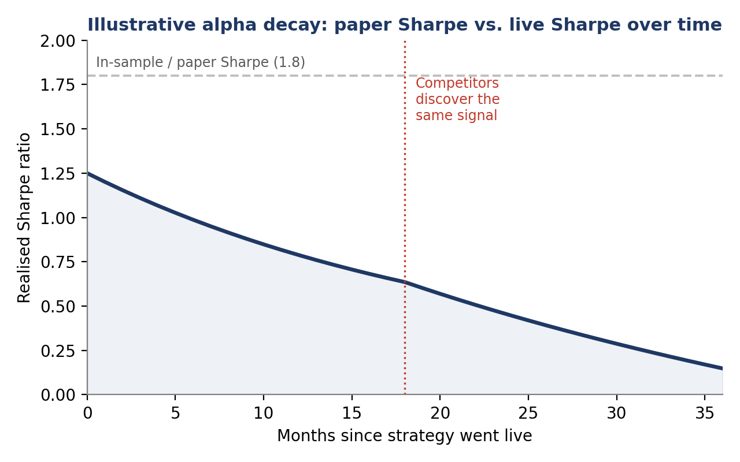
Figure 6.1 — Illustrative alpha decay: a strategy with a 1.8 in-sample Sharpe realises roughly 1.1 at launch (the usual in-sample-to-live gap), then declines further as the underlying signal weakens and, from month 18 onward, as competitors discover and crowd the same trade.
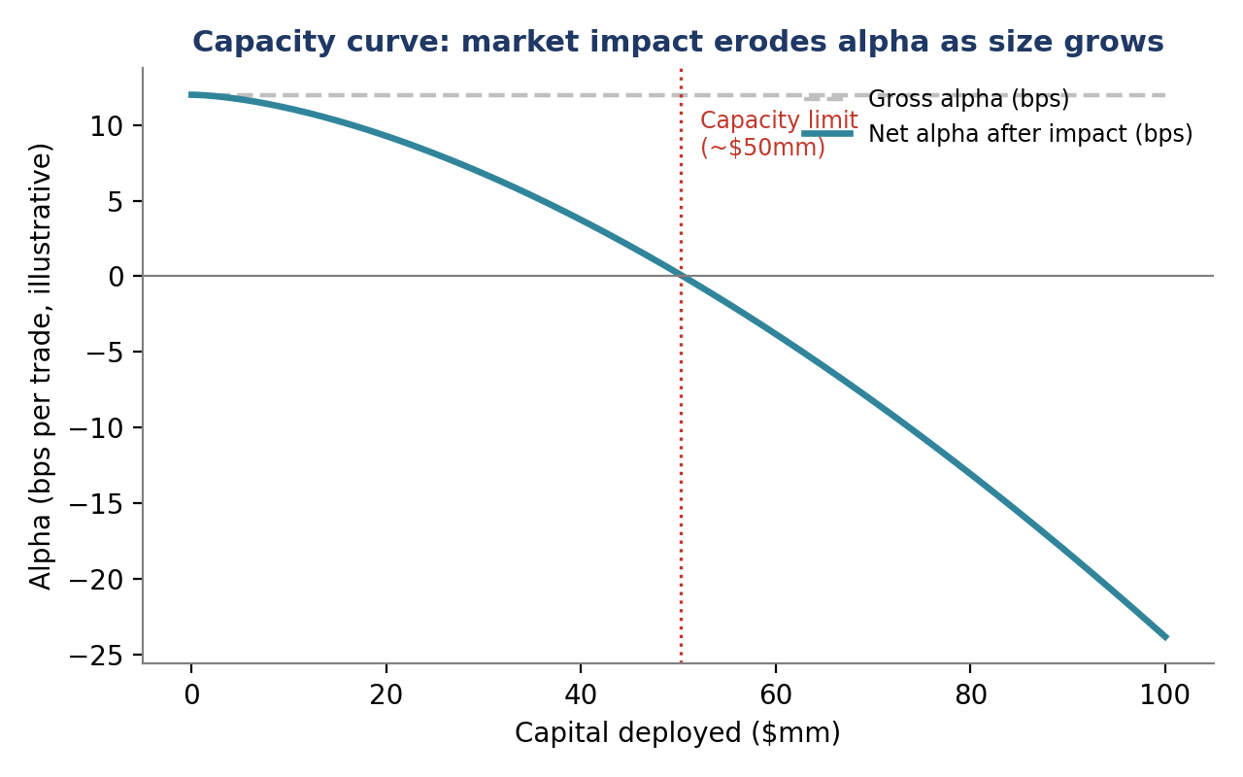
Figure 6.3 — Illustrative capacity curve: gross alpha per trade is roughly constant, but market impact grows convexly with size deployed, producing a capacity limit beyond which the strategy destroys value rather than creating it.
Worked example: estimating a rough capacity limit
- A signal generates a theoretical 12bps of edge per trade before costs. Empirically, trading X% of a stock’s average daily volume moves the price against the strategy by roughly 0.9×(X/10)^1.6 bps (a stylised square-root-like impact model).
- Net alpha turns negative once impact cost exceeds 12bps — in this illustrative model, that occurs at roughly $50mm of capital deployed per the assumptions in Figure 6.3, though the real number depends entirely on the liquidity of the specific instruments traded.
- A prudent research team sizes a strategy well below its estimated capacity — often at 20–40% of the point where net alpha is estimated to reach zero — to leave a buffer for the same instrument to become less liquid, for the impact model itself to be wrong, and for other participants to independently discover the same trade.

6.4 Data Quality
A research conclusion is only as trustworthy as the data it was tested on. Several data-quality failure modes recur often enough in systematic research that they deserve to be checked explicitly on every project, not assumed away.

Issue | What goes wrong | Typical mitigation
Survivorship bias | A universe built from today’s constituents silently excludes companies that went bankrupt, were delisted or were acquired, flattering historical returns | Use point-in-time index membership and include delisted/defunct securities in the backtest universe
Look-ahead bias | A feature uses information that would not actually have been available at the decision timestamp — e.g. a restated fundamental figure, or an end-of-day price used for an intraday decision | Timestamp every data field with its actual availability/publication time, not the period it describes
Point-in-time vs. restated data | Financial statement data is frequently revised after initial release; using the latest (restated) figures overstates what a real-time model could have known | Use point-in-time database vintages that reconstruct what was known on each historical date
Corporate actions | Unadjusted or incorrectly adjusted prices around splits, dividends and spin-offs create phantom returns or gaps | Use total-return series adjusted consistently for all corporate actions
Data vendor errors | Bad ticks, duplicated rows, timezone misalignment and stale quotes are common even in paid, ‘clean’ datasets | Automated sanity checks (bounds, cross-vendor reconciliation) as a standing part of the data pipeline, not a one-off audit

The common thread across all of these is time: a backtest is a simulation of a decision made at a specific historical instant, and any data that would not genuinely have been available and correct at that instant introduces an advantage the live strategy will never actually have.

6.5 Research Reproducibility
A result that cannot be reproduced is not yet a result — it is an anecdote. Reproducibility means that the same code, run against the same data and configuration, produces the same output, and that a colleague (or the same researcher, six months later) can regenerate a reported backtest exactly, not approximately.
- Data versioning: Snapshot or version the exact dataset used for a result, so a later data-vendor correction or index reconstitution does not silently change what a historical report shows.
- Code and environment pinning: Record the exact code revision, library versions and configuration used to produce a result, since a library update or a default-parameter change can alter backtest output without any visible code change.
- Random seed control: Any strategy or validation procedure with a stochastic element (cross-validation folds, bootstrapped confidence intervals, ML model initialisation) should fix and record its seed so results can be exactly regenerated.
- Independent re-run: Before a strategy is sized and deployed, a second researcher (or an automated pipeline) re-runs the full research process from raw data to final report, catching silent dependencies on a specific machine, file path or notebook execution order.
This is precisely the discipline that reproducibility infrastructure (Level 4 of the Development track) exists to support: pipelines that make it cheap and automatic to snapshot data, pin environments and re-run research remove the excuse to skip these steps under deadline pressure.

6.6 Researcher Degrees of Freedom & Multiple Hypothesis Testing
A ‘researcher degree of freedom’ is any choice made during a research process that could plausibly have been made differently, and that was chosen — consciously or not — partly because it produced a better-looking result. Which universe of instruments to include or exclude, which lookback window to use, which outlier-handling rule to apply, which of several similar signals to report, how many parameter combinations to try before settling on one: each of these is a fork in the road, and each fork is an opportunity, invisible in the final report, for noise to be mistaken for skill.
This connects directly to multiple hypothesis testing. A single well-specified backtest that clears a conventional significance bar is meaningful evidence. The same backtest, selected as the single best result out of 500 variations that were tried and discarded, is close to meaningless — and the published report, showing only the winning variation, gives no way for a reader to tell the two situations apart. The number of ‘looks’ taken at the data, not just the result of the final look, is what determines how much a Sharpe ratio should be trusted.
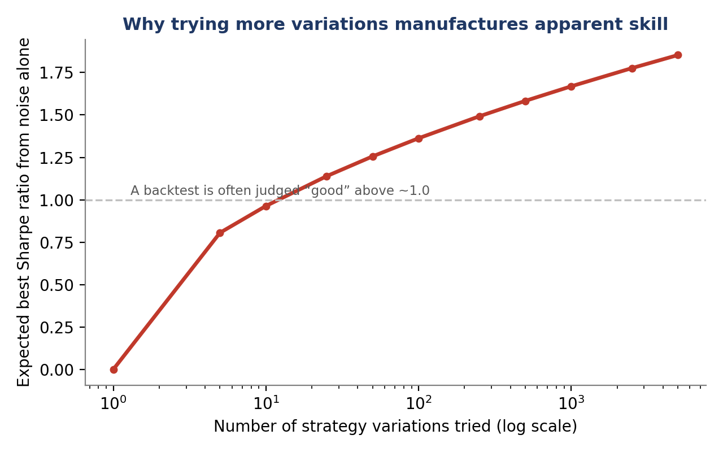
Figure 6.2 — The expected best Sharpe ratio obtainable from pure noise (a stylised extreme-value approximation over ~5 years of daily data) rises steadily with the number of independent variations tried, illustrating why an unadjusted, cherry-picked backtest result can look skillful even with zero true edge.
The deflated Sharpe ratio
One widely used correction, the deflated Sharpe ratio, adjusts an observed Sharpe ratio for the number of trials, the variance across those trials, and the length of the backtest, producing the probability that the true Sharpe ratio exceeds a chosen benchmark (often zero) after accounting for the search that produced the result. A high raw Sharpe ratio found after an extensive, poorly tracked search can deflate to a statistically unremarkable figure once the number of trials is properly accounted for.
Worked example: how trial count changes interpretation
- A researcher reports a backtest with an annualised Sharpe ratio of 1.4 over five years of daily data (roughly 1,250 observations).
- If this was the only variation tested, a Sharpe of 1.4 is a genuinely strong, credible result, comfortably above what noise alone would typically produce.
- If it was the best of roughly 500 variations tried (different lookbacks, universes and parameter combinations), Figure 6.2 shows that pure noise alone would be expected to produce a best-of-500 Sharpe in a similar range — so the same reported number now carries far weaker evidence of real skill, and a deflated Sharpe calculation would confirm the loss of statistical significance.

6.7 False Discoveries — Detection and Guardrails
A false discovery is a strategy that appears to work in research but has no real edge — the backtest result is, in effect, noise that survived the search process described in §6.6. Because false discoveries are indistinguishable from real edges by looking at the backtest alone, guarding against them requires structural safeguards built into the research process itself, rather than relying on judgement applied after the fact.
- True out-of-sample holdout: Reserve a period of data that is never touched, viewed or used to inform any decision during research, and test the final, fully-specified strategy against it exactly once.
- Walk-forward validation: Repeatedly train on a historical window and test on the immediately following, unseen window, rolling forward through time, to check that a strategy’s parameters are not implicitly fit to a single period.
- Tracking the search: Log every variation attempted — not just the ones that worked — so the true number of ‘looks’ at the data is known and can feed a multiple-testing correction such as the deflated Sharpe ratio.
- Probability of backtest overfitting (PBO): A resampling-based estimate of the probability that the strategy selected as best in-sample will underperform the median of the candidate strategies out-of-sample — a high PBO is a direct warning sign of overfitting.
- Independent replication: Before capital is committed, have a second researcher, blind to the original search process, attempt to reproduce the finding from the stated economic hypothesis and a fresh look at the data.
⚠ Why this matters more than it first appears
- A research team running many parallel projects will, by construction, produce some false discoveries even if every individual researcher acts in good faith — multiple testing operates at the team level, not just within one person’s search.
- Without team-level tracking of how many strategies were tried across all researchers, a firm can systematically overestimate its own hit rate and mis-size capital allocated to ‘successful’ strategies.

6.8 Worked Exercise — Model Answer
Exercise: Audit one of your own past strategies for researcher degrees of freedom — list every parameter, universe choice and data cut you tried before settling on the final version, and estimate how much of the reported Sharpe ratio might be attributable to that search.
Model answer structure
- Reconstruct the search log. Even without a formal record, most researchers can recall roughly how many lookback windows (e.g. 20, 60, 120, 252 days), how many universe definitions (e.g. all-cap vs. liquid-only), and how many parameter grids were tried before the final version was chosen. Write these down explicitly, including combinations that were tried and abandoned.
- Estimate an effective trial count. Some choices are correlated (trying 20- and 21-day lookbacks is not really two independent trials), so the effective number of independent ‘looks’ is usually smaller than the raw count of runs — a reasonable audit rounds to an order of magnitude (e.g. ‘roughly 30–50 effectively distinct variations’) rather than false precision.
- Compare against Figure 6.2. Locate the effective trial count on the expected-best-Sharpe-from-noise curve and compare it to the strategy’s reported Sharpe ratio; a reported Sharpe only modestly above the noise-alone expectation for that trial count is weak evidence of a real edge.
- Compute (or approximate) a deflated Sharpe ratio using the effective trial count, the reported Sharpe, and the length of the backtest, and report this adjusted figure alongside the raw Sharpe ratio going forward, not instead of it.
- Decide on a forward action: strategies whose deflated Sharpe is no longer statistically distinguishable from zero should be re-validated on genuinely new, never-touched data before being trusted further, sized down, or retired.

6.9 Common Mistakes — Deeper Look
Mistake: Not tracking how many strategy variations were tried before finding one that worked
This is invisible multiple testing, and it is invisible precisely because nothing about the final backtest report reveals it. Two researchers can produce an identical-looking one-page summary of a 1.5 Sharpe strategy; if one tried a single well-motivated specification and the other tried three hundred, the two results carry very different amounts of evidence, but a reader with only the final report cannot tell them apart. The fix is procedural, not statistical: log every variation attempted, including the ones discarded, as a standing part of the research workflow rather than an afterthought performed only when a result looks suspicious.
Mistake: Treating a strategy’s initial backtest Sharpe as its expected live Sharpe, ignoring decay and crowding
Even a strategy built with genuine economic reasoning and disciplined trial-tracking will typically see live performance below its backtest, for reasons that have nothing to do with overfitting: transaction costs are usually underestimated in a backtest, the market continues to evolve after the sample period ends, and other participants who read the same academic literature or observe the same market inefficiency will eventually compress the same edge (§6.3). Sizing a strategy, or setting risk limits, off the backtest Sharpe alone — rather than a deliberately conservative, decay-adjusted estimate — is a direct route to being over-levered exactly when the edge is weakest.
⚠ Case study: a quantitative fund undone by crowding
- In August 2007, several large quantitative equity funds running structurally similar statistical arbitrage strategies experienced sharp, simultaneous losses over a matter of days, even though none of the underlying fundamental or macroeconomic conditions had changed materially.
- The proximate cause was widely attributed to one or more large funds being forced to rapidly unwind similar positions (for reasons unrelated to the strategies’ own signals), which pushed prices in a way that hurt every other fund holding the same crowded trades, and which then triggered further deleveraging in a feedback loop.
- The episode is a standing illustration that a strategy’s risk is not fully described by its own historical volatility when many other participants hold highly correlated positions — crowding risk can materialise suddenly and simultaneously across otherwise-unrelated funds.

6.10 Advanced Extensions
- Formal pre-registration of research hypotheses: Committing, in writing and before touching the relevant data, to the specific hypothesis, universe, sample period and success criterion a project will use — borrowed from the pre-registration movement in experimental science — makes researcher degrees of freedom explicit and auditable rather than reconstructed after the fact.
- Deflated Sharpe ratio and related multiple-testing-corrected metrics: Beyond the deflated Sharpe ratio introduced in §6.6, related tools include the probability of backtest overfitting (PBO, §6.7), the family-wise error rate and false discovery rate corrections adapted from statistics, and haircut/shrinkage approaches that systematically discount reported Sharpe ratios based on how they were obtained.

6.11 Professional Applications
- Research governance at systematic funds: Formal committees or processes that review a strategy’s full search history, out-of-sample validation and capacity estimate before capital is allocated, rather than relying on the researcher’s own backtest report alone.
- Honest self-assessment of strategy pipelines: Firm-level tracking of how many strategies are researched versus how many are ultimately deployed and how many of those retain their edge after a fixed period live, which turns the abstract discipline of this section into a measurable, improvable process rather than a one-time audit.

